

9150 Hwy 1431 W Buchanan Dam, TX 78609

512-793-5463 512-793-5203 (fax)

[hillcountryhs@gmail.com](mailto:hillcountryhs@gmail.com)

[www.hillcountryhumansociety.org](http://www.hillcountryhumansociety.org)

**WISH LIST**

**HEAVY DUTY KONGS (Black) KONGS (Red)**

**PURINA COMPLETE DRY DOG FOOD MILK BONES (All Sizes)**

**PURINA COMPLETE DRY PUPPY FOOD BLEACH**

**PURINA DRY COMPLETE CAT & KITTEN FOOD TOWELS**

**LITTER (LOW DUST AND NON-CLUMPING) PILL POCKETS**

**DOG TOYS CAT TOYS**

**TENNIS BALLS LATEX GLOVES**

**LAUNDRY SOAP DRYER SHEETS**

**PAPER TOWELS TOILET PAPER**

**BLANKETS DAWN**

**TRASH BAGS (13 AND 33 GALLON) COLLARS & LEASHES**

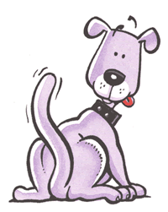 **K**

**THANK YOU**